Activity No.3
Aim: Preparing the UTP cable for cross and direct connection using Crimping Tools.

Requirements:
Crimping tools, UTP Cable, RJ-45 connector, Cable tester.

Procedure:
Crimping Tools:
A crimping tool is a device used to conjoin two pieces of metal by deforming one or both of them to hold each other. The result of the tool's work is called a crimp. An example of crimping is affixing a connector to the end of a cable. For instance, network cables and phone cables are created using a crimping tool (shown below) to join RJ-45 and RJ-11 connectors to both ends of phone or Cat 5 cable.
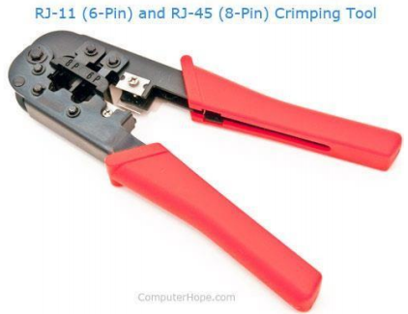
UTP Cables:
UTP stands for Unshielded Twisted Pair cable. UTP cable is a 100 ohm copper cable that consists of 2 to 1800 unshielded twisted pairs surrounded by an outer jacket. They have no metallic shield. This makes the cable small in diameter but unprotected against electrical interference. The twist helps to improve its immunity to electrical noise and EMI.
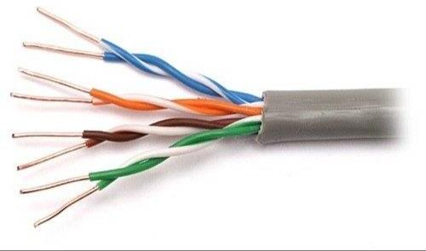

RJ-45 Connector:
RJ-45 connector is a tool that we put on the end of the UTP cable. With this we can plug the cable in the LAN port.
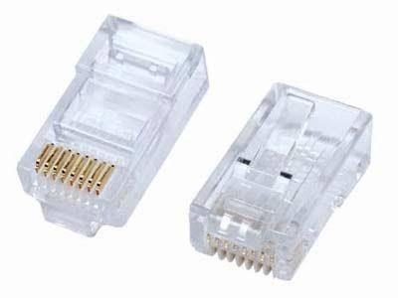
Straight cable:
A straight-through cable is a type of twisted pair cable that is used in local area networks to connect a computer to a network hub such as a router. This type of cable is also sometimes called a patch cable and is an alternative to wireless connections where one or more computers access a router through a wireless signal. On a straight-through cable, the wired pins match. Straight through cable use one wiring standard: both ends use T568A wiring standard or both ends use T568B wiring standard. The following figure shows a straight-through cable of which both ends are wired as the T568B standard.
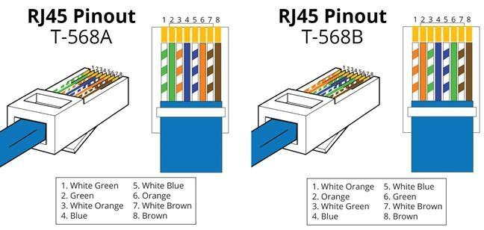

Cross cable:
An Ethernet crossover cable is a type of Ethernet cable used to connect computing devices together directly. Unlike straight-through cable, crossover cables use two different wiring standards . It is most often used to connect two devices of the same type: e.g. two computers (via network interface controller) or two switches to each other.
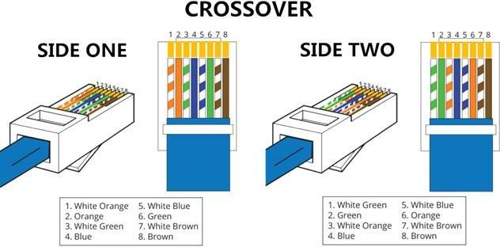

Making Straight UTP Cable:
- Peel the end of the UTP cable , approximately 2 cm.
- Open the cable strands , align and follow the arrangement as standard cable image shown below .
- Once the order is according to the standard , cut and flatten the ends of the cable,
- Put the cable is straight and aligned into the RJ - 45 connector , and make sure all cables are in correct position as follows:

Orange White on no 1
Orange on no 2
Green White on no 3
Blue on no 4
Blue White on no 5
Green on no 6
White Brown on no 7
Brown on no 8
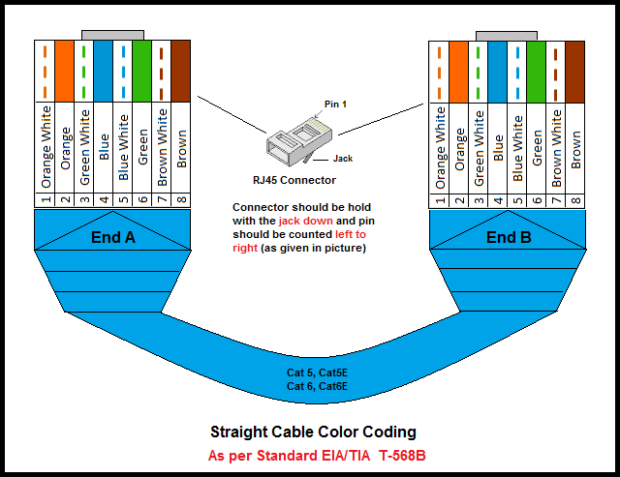

- Make crimping using crimp tools , press crimping tool and make sure all the pins ( brass ) on the RJ - 45 connector has " bite " of each cable . usually when done will sound "click ". Once finished at the end of this one , do it again at the other end cable. The final step is to check the cable that you created earlier using the LAN tester , enter each end of the cable ( RJ- 45 ) to each LAN port available on the tester , turn and make sure all of the LEDs light up according to the order of the wires we created.

Creating Cross UTP Cable:-
Creating a cross cable has almost the same steps with straight cable , the difference lies only in the colour sequence from both ends of the cable . Unlike the straight cable that has the same colour sequence at both ends of the cable , the cross cable has a different colour sequences atboth ends of the cable. The first ends is same with straight cable :

Orange White on no. 1
Orange on no. 2
Green White on no. 3
Blue on no. 4
Blue White on no. 5
Green on no. 6 .
White chocolate on no. 7
Brown on no. 8
For the second end of the cable, the colour composition is different from the first . The colour arrangement is as follows
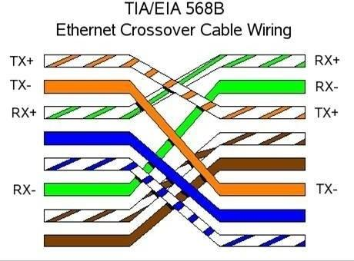
Green White on no. 1
Green on no. 2Orange White on no. 3
Blue on no. 4
Blue White on no. 5
Orange on no. 6
White chocolate no.7
Brown on no.8
